Test Case: tc002_SPX_Dev5_Crear_Requisicion_Spot_Con_FAD_Tipo_Cobro_CC
Step 1 - Enter username and password and click to button Enter : Credentials Entered
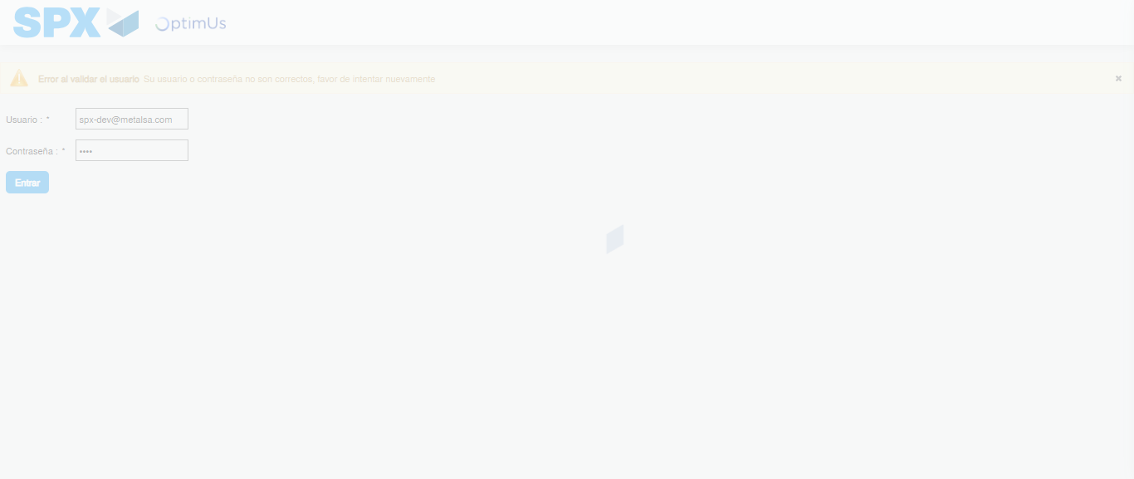Image file-name: QC_Testing-tc002_SPX_Dev5_Crear_Requisicion_Spot_Con_FAD_Tipo_Cobro_CC-1790170463101

Step 2 - Select to UEN and Access to Spot Buy Requisitions : UEN Correctly selected and Correct access
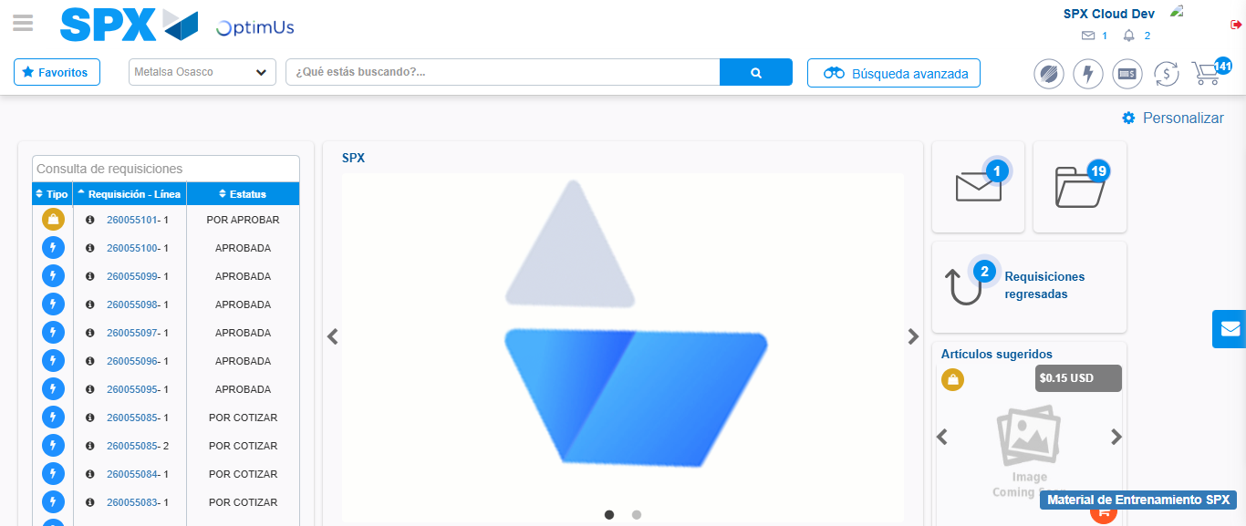Image file-name: QC_Testing-tc002_SPX_Dev5_Crear_Requisicion_Spot_Con_FAD_Tipo_Cobro_CC-1790170488128

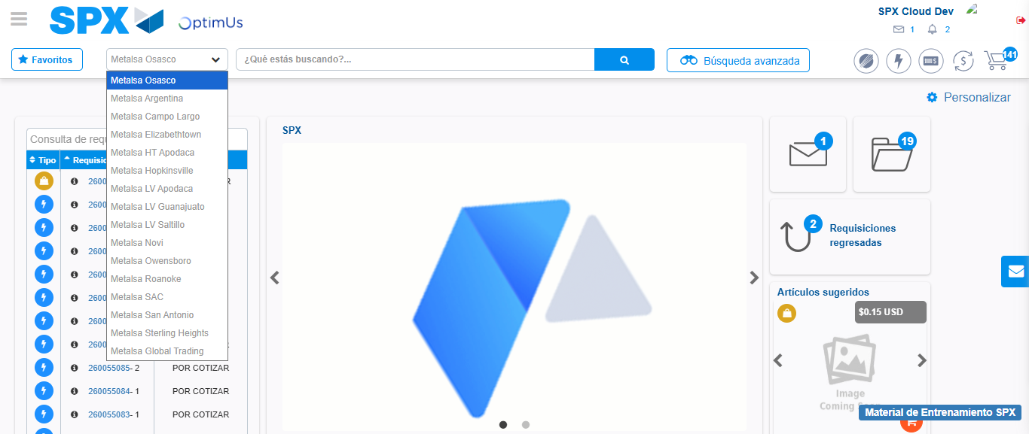Image file-name: QC_Testing-tc002_SPX_Dev5_Crear_Requisicion_Spot_Con_FAD_Tipo_Cobro_CC-1790170488754

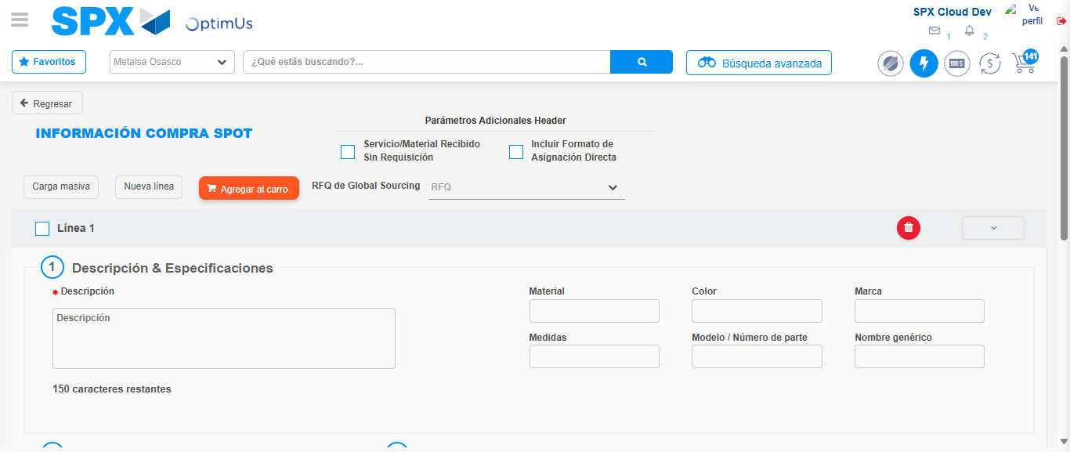Image file-name: QC_Testing-tc002_SPX_Dev5_Crear_Requisicion_Spot_Con_FAD_Tipo_Cobro_CC-1790170492841

Step 3 - Add FAD to Requisition: FAD Successfully Added
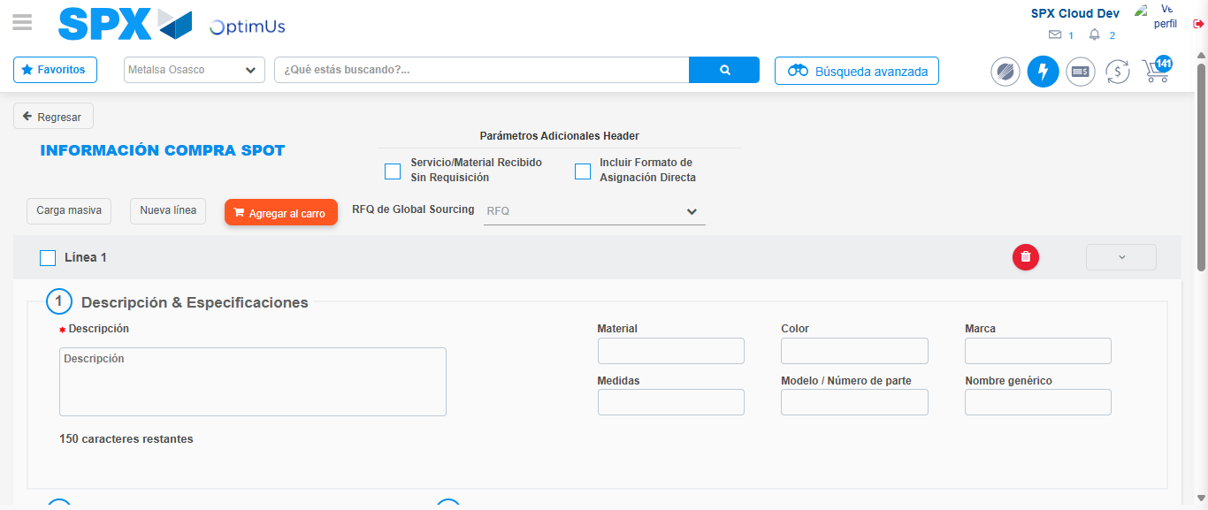Image file-name: QC_Testing-tc002_SPX_Dev5_Crear_Requisicion_Spot_Con_FAD_Tipo_Cobro_CC-1790170493158

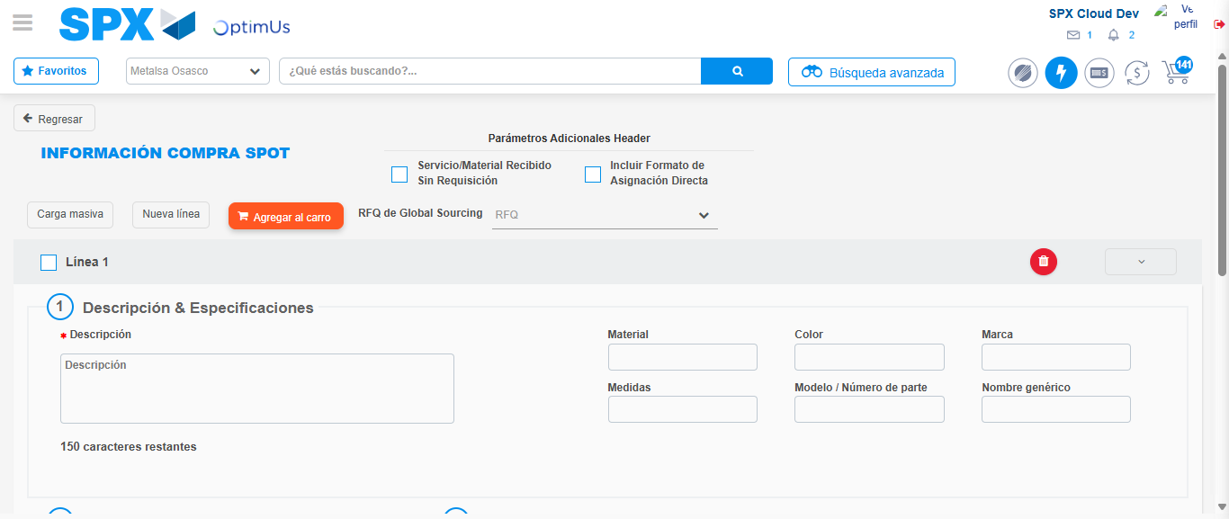Image file-name: QC_Testing-tc002_SPX_Dev5_Crear_Requisicion_Spot_Con_FAD_Tipo_Cobro_CC-1790170493405

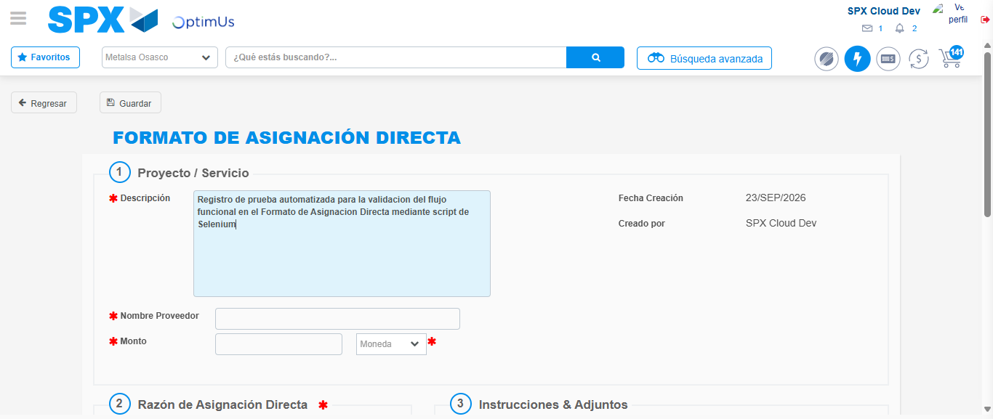Image file-name: QC_Testing-tc002_SPX_Dev5_Crear_Requisicion_Spot_Con_FAD_Tipo_Cobro_CC-1790170496257

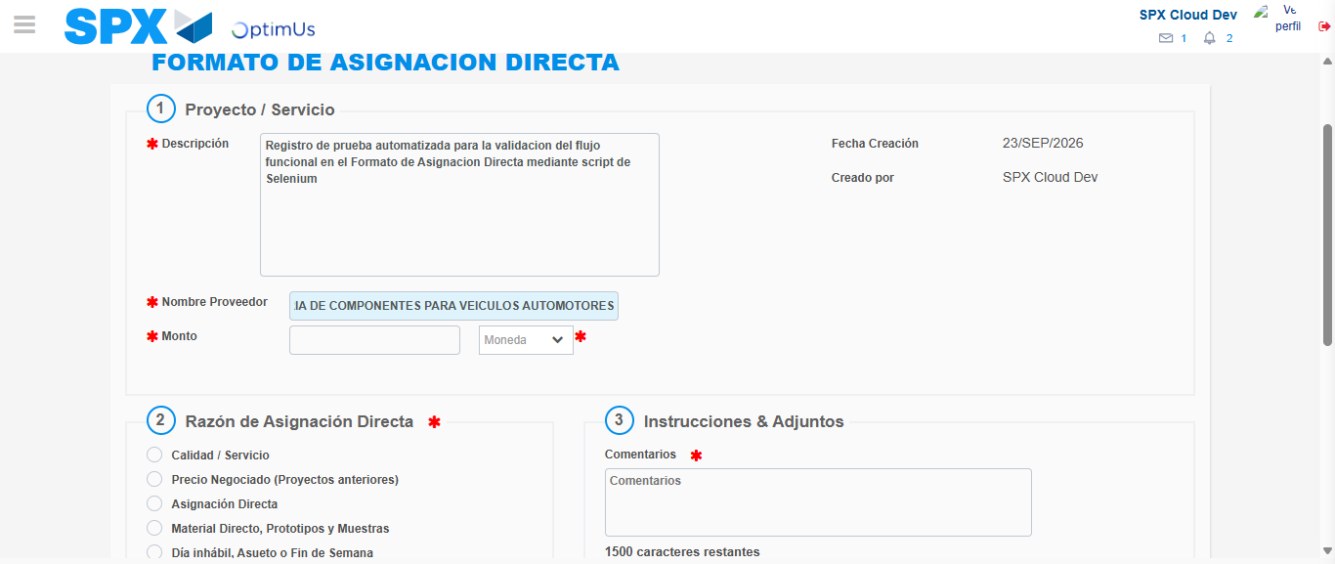Image file-name: QC_Testing-tc002_SPX_Dev5_Crear_Requisicion_Spot_Con_FAD_Tipo_Cobro_CC-1790170505620

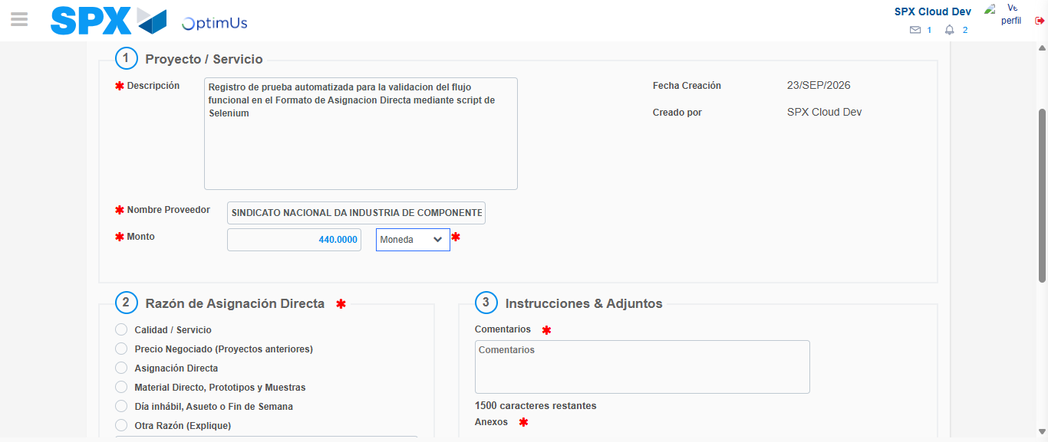Image file-name: QC_Testing-tc002_SPX_Dev5_Crear_Requisicion_Spot_Con_FAD_Tipo_Cobro_CC-1790170506078

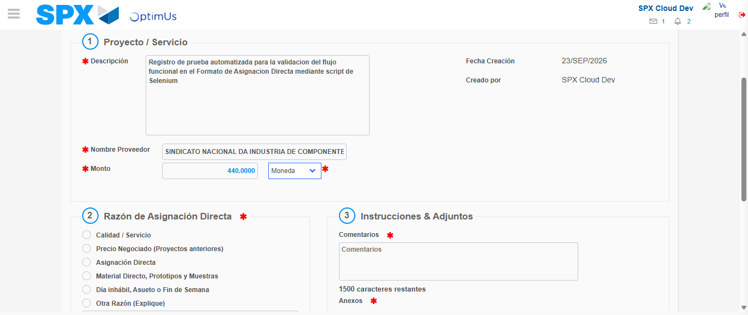Image file-name: QC_Testing-tc002_SPX_Dev5_Crear_Requisicion_Spot_Con_FAD_Tipo_Cobro_CC-1790170506307

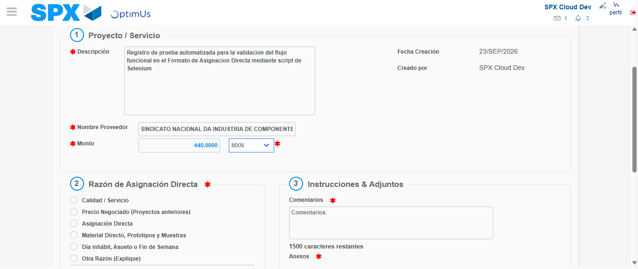Image file-name: QC_Testing-tc002_SPX_Dev5_Crear_Requisicion_Spot_Con_FAD_Tipo_Cobro_CC-1790170506666

Image file-name: QC_Testing-tc002_SPX_Dev5_Crear_Requisicion_Spot_Con_FAD_Tipo_Cobro_CC-1790170506869

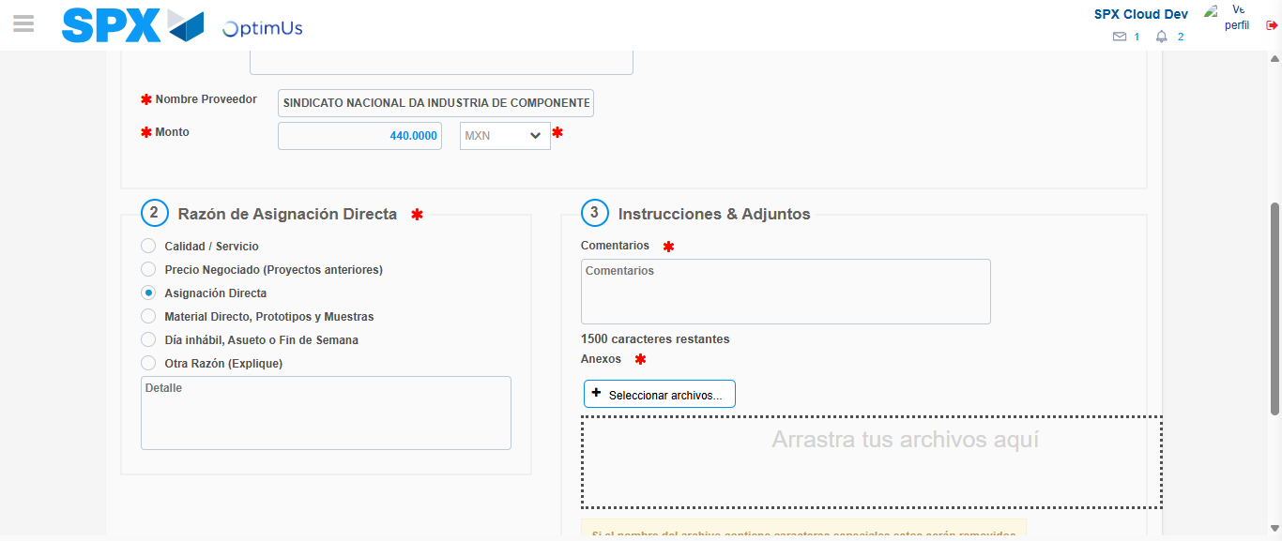Image file-name: QC_Testing-tc002_SPX_Dev5_Crear_Requisicion_Spot_Con_FAD_Tipo_Cobro_CC-1790170507738

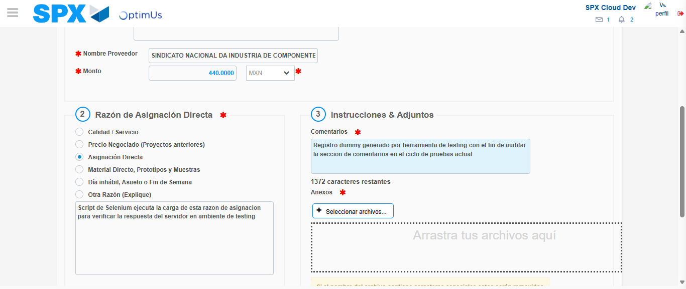Image file-name: QC_Testing-tc002_SPX_Dev5_Crear_Requisicion_Spot_Con_FAD_Tipo_Cobro_CC-1790170518872

Image file-name: QC_Testing-tc002_SPX_Dev5_Crear_Requisicion_Spot_Con_FAD_Tipo_Cobro_CC-1790170519675

Step 4 - Data Capture Spot Buy Requisition: Data captured correctly
Image file-name: QC_Testing-tc002_SPX_Dev5_Crear_Requisicion_Spot_Con_FAD_Tipo_Cobro_CC-1790170493158

Image file-name: QC_Testing-tc002_SPX_Dev5_Crear_Requisicion_Spot_Con_FAD_Tipo_Cobro_CC-1790170493405

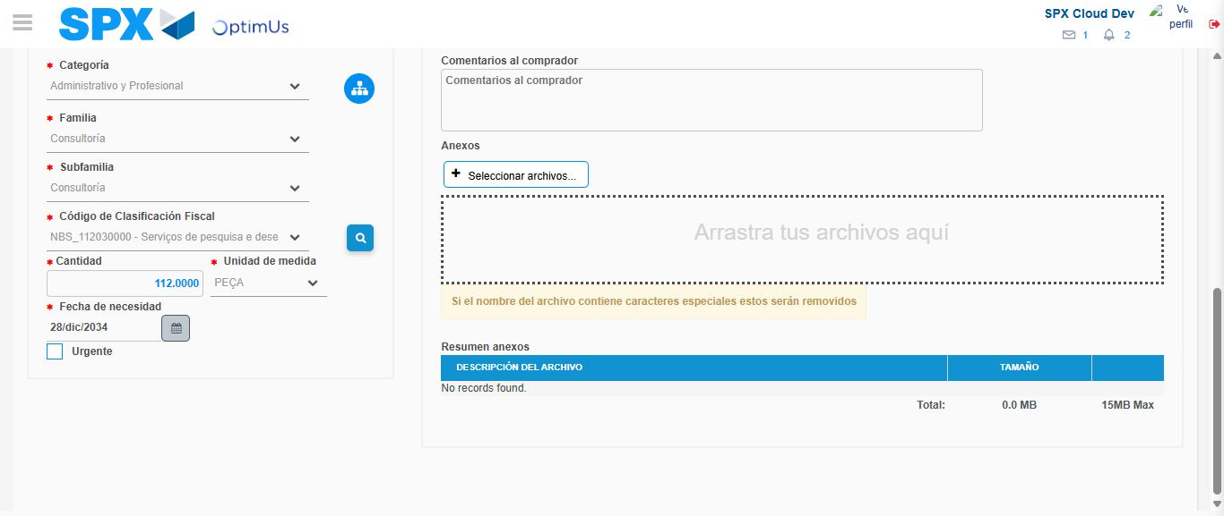Image file-name: QC_Testing-tc002_SPX_Dev5_Crear_Requisicion_Spot_Con_FAD_Tipo_Cobro_CC-1790170538965

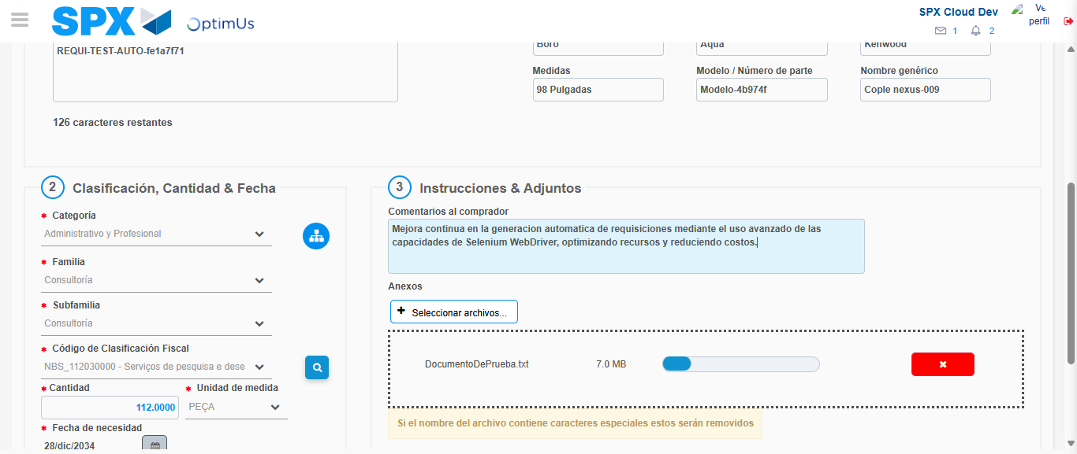Image file-name: QC_Testing-tc002_SPX_Dev5_Crear_Requisicion_Spot_Con_FAD_Tipo_Cobro_CC-1790170539832

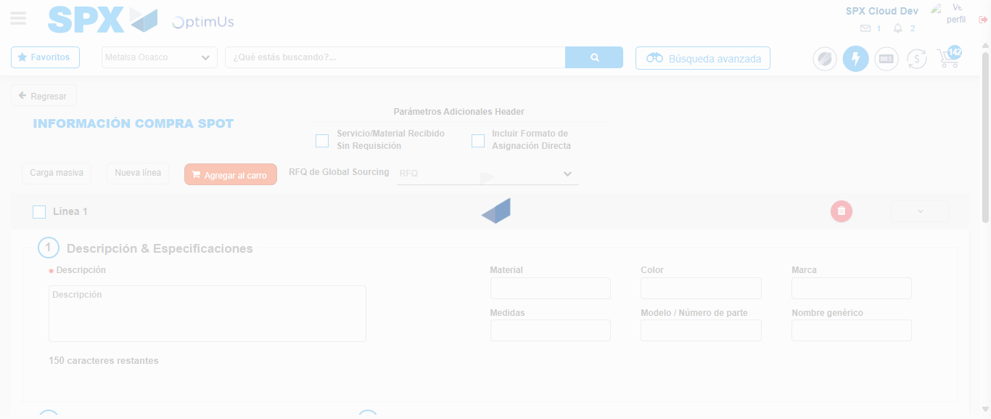Image file-name: QC_Testing-tc002_SPX_Dev5_Crear_Requisicion_Spot_Con_FAD_Tipo_Cobro_CC-1790170554211

Step 8 - Return to Main Page SPX : Return to Main Page SPX
Image file-name: QC_Testing-tc002_SPX_Dev5_Crear_Requisicion_Spot_Con_FAD_Tipo_Cobro_CC-1790170488128

Image file-name: QC_Testing-tc002_SPX_Dev5_Crear_Requisicion_Spot_Con_FAD_Tipo_Cobro_CC-1790170488754

Image file-name: QC_Testing-tc002_SPX_Dev5_Crear_Requisicion_Spot_Con_FAD_Tipo_Cobro_CC-1790170492841

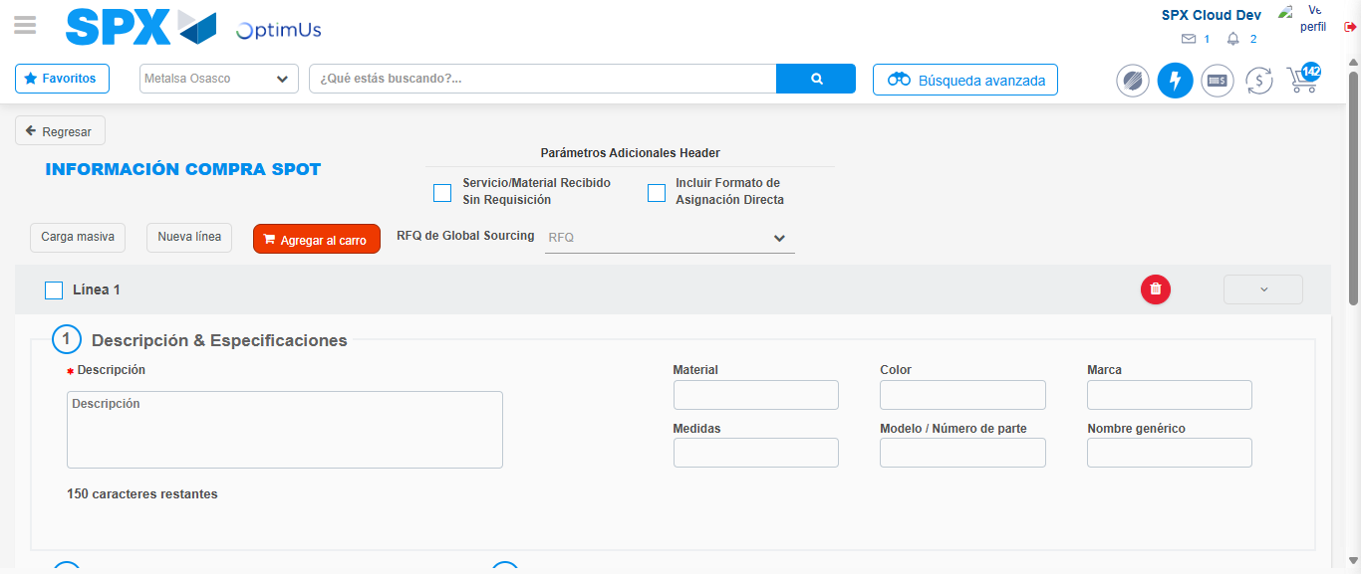Image file-name: QC_Testing-tc002_SPX_Dev5_Crear_Requisicion_Spot_Con_FAD_Tipo_Cobro_CC-1790170556430

Image file-name: QC_Testing-tc002_SPX_Dev5_Crear_Requisicion_Spot_Con_FAD_Tipo_Cobro_CC-1790170556631

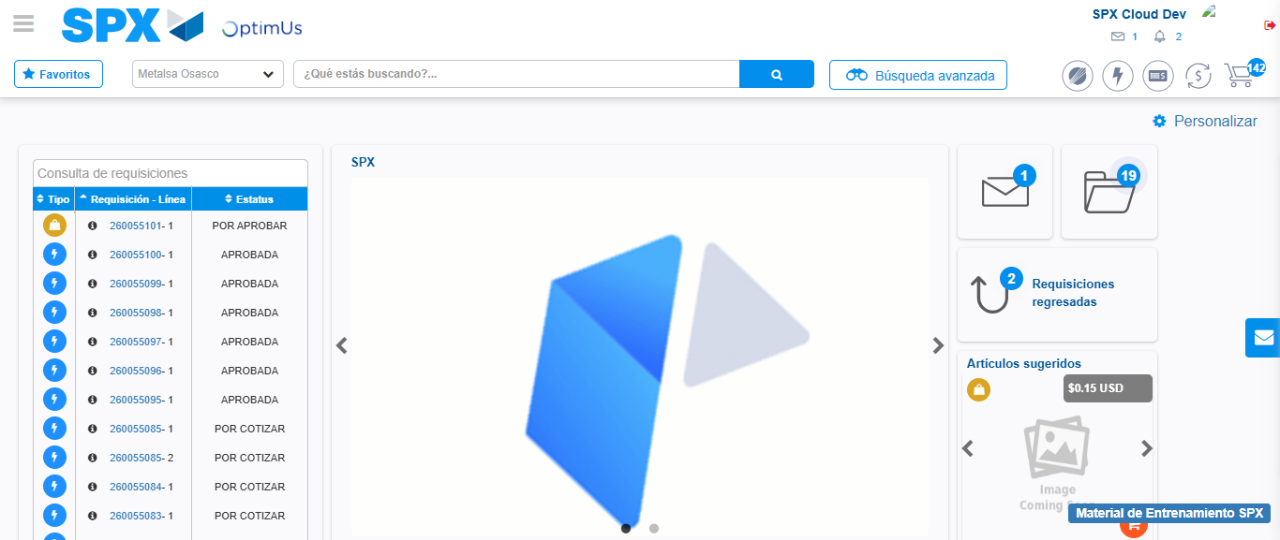Image file-name: QC_Testing-tc002_SPX_Dev5_Crear_Requisicion_Spot_Con_FAD_Tipo_Cobro_CC-1790170577900

Step 9 - Log Out : Log Out SPX
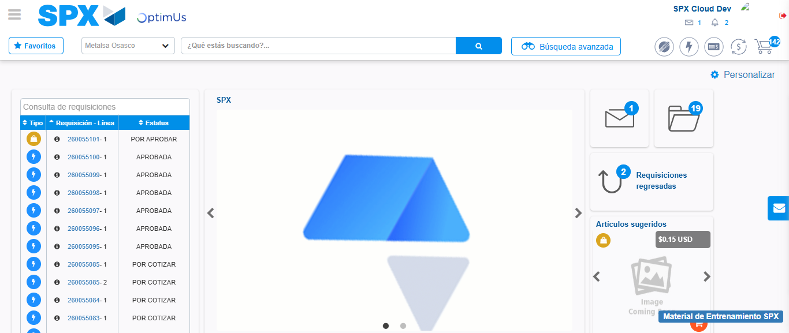Image file-name: QC_Testing-tc002_SPX_Dev5_Crear_Requisicion_Spot_Con_FAD_Tipo_Cobro_CC-1790170578298

